# Load packages
> library(bayesrules)
> library(tidyverse)
> library(rstanarm)
> library(bayesplot)
> library(tidybayes)
> library(broom.mixed)
> # Load data
> data(cherry_blossom_sample)
> running <- cherry_blossom_sample
> # Remove NAs
> running <- running %>%
+ select(runner, age, net) %>%
+ na.omit()
> #17.1
>
> # Posterior summary statistics
> model_summary <- tidy(complete_pooled_model,
+ conf.int = TRUE, conf.level = 0.80)
> model_summary
# A tibble: 2 × 5
term estimate std.error conf.low conf.high
<chr> <dbl> <dbl> <dbl> <dbl>
1 (Intercept) 75.2 24.6 43.7 106.
2 age 0.268 0.446 -0.302 0.842
> # A tibble: 2 x 5
> # Posterior median model
> B0 <- model_summary$estimate[1]
> B1 <- model_summary$estimate[2]
> ggplot(running, aes(x = age, y = net)) +
+ geom_point() +
+ geom_abline(aes(intercept = B0, slope = B1))

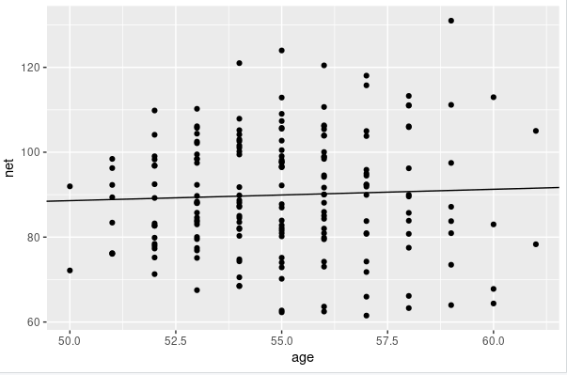

> running_model_1_prior <- stan_glmer(
+ net ~ age + (1 | runner),
+ data = running, family = gaussian,
+ prior_intercept = normal(100, 10),
+ prior = normal(2.5, 1),
+ prior_aux = exponential(1, autoscale = TRUE),
+ prior_covariance = decov(reg = 1, conc = 1, shape = 1, scale = 1),
+ chains = 4, iter = 5000*2, seed = 84735,
+ prior_PD = TRUE)

SAMPLING FOR MODEL 'continuous' NOW (CHAIN 1).
Chain 1:
Chain 1: Gradient evaluation took 3.5e-05 seconds
Chain 1: 1000 transitions using 10 leapfrog steps per transition would take 0.35 seconds.
Chain 1: Adjust your expectations accordingly!
Chain 1:
Chain 1:
Chain 1: Iteration: 1 / 10000 [ 0%] (Warmup)
Chain 1: Iteration: 1000 / 10000 [ 10%] (Warmup)
Chain 1: Iteration: 2000 / 10000 [ 20%] (Warmup)
Chain 1: Iteration: 3000 / 10000 [ 30%] (Warmup)
Chain 1: Iteration: 4000 / 10000 [ 40%] (Warmup)
Chain 1: Iteration: 5000 / 10000 [ 50%] (Warmup)
Chain 1: Iteration: 5001 / 10000 [ 50%] (Sampling)
Chain 1: Iteration: 6000 / 10000 [ 60%] (Sampling)
Chain 1: Iteration: 7000 / 10000 [ 70%] (Sampling)
Chain 1: Iteration: 8000 / 10000 [ 80%] (Sampling)
Chain 1: Iteration: 9000 / 10000 [ 90%] (Sampling)
Chain 1: Iteration: 10000 / 10000 [100%] (Sampling)
Chain 1:
Chain 1: Elapsed Time: 0.705467 seconds (Warm-up)
Chain 1: 0.752047 seconds (Sampling)
Chain 1: 1.45751 seconds (Total)
Chain 1:

SAMPLING FOR MODEL 'continuous' NOW (CHAIN 2).
Chain 2:
Chain 2: Gradient evaluation took 2.2e-05 seconds
Chain 2: 1000 transitions using 10 leapfrog steps per transition would take 0.22 seconds.
Chain 2: Adjust your expectations accordingly!
Chain 2:
Chain 2:
Chain 2: Iteration: 1 / 10000 [ 0%] (Warmup)
Chain 2: Iteration: 1000 / 10000 [ 10%] (Warmup)
Chain 2: Iteration: 2000 / 10000 [ 20%] (Warmup)
Chain 2: Iteration: 3000 / 10000 [ 30%] (Warmup)
Chain 2: Iteration: 4000 / 10000 [ 40%] (Warmup)
Chain 2: Iteration: 5000 / 10000 [ 50%] (Warmup)
Chain 2: Iteration: 5001 / 10000 [ 50%] (Sampling)
Chain 2: Iteration: 6000 / 10000 [ 60%] (Sampling)
Chain 2: Iteration: 7000 / 10000 [ 70%] (Sampling)
Chain 2: Iteration: 8000 / 10000 [ 80%] (Sampling)
Chain 2: Iteration: 9000 / 10000 [ 90%] (Sampling)
Chain 2: Iteration: 10000 / 10000 [100%] (Sampling)
Chain 2:
Chain 2: Elapsed Time: 0.680688 seconds (Warm-up)
Chain 2: 0.726351 seconds (Sampling)
Chain 2: 1.40704 seconds (Total)
Chain 2:

SAMPLING FOR MODEL 'continuous' NOW (CHAIN 3).
Chain 3:
Chain 3: Gradient evaluation took 2.2e-05 seconds
Chain 3: 1000 transitions using 10 leapfrog steps per transition would take 0.22 seconds.
Chain 3: Adjust your expectations accordingly!
Chain 3:
Chain 3:
Chain 3: Iteration: 1 / 10000 [ 0%] (Warmup)
Chain 3: Iteration: 1000 / 10000 [ 10%] (Warmup)
Chain 3: Iteration: 2000 / 10000 [ 20%] (Warmup)
Chain 3: Iteration: 3000 / 10000 [ 30%] (Warmup)
Chain 3: Iteration: 4000 / 10000 [ 40%] (Warmup)
Chain 3: Iteration: 5000 / 10000 [ 50%] (Warmup)
Chain 3: Iteration: 5001 / 10000 [ 50%] (Sampling)
Chain 3: Iteration: 6000 / 10000 [ 60%] (Sampling)
Chain 3: Iteration: 7000 / 10000 [ 70%] (Sampling)
Chain 3: Iteration: 8000 / 10000 [ 80%] (Sampling)
Chain 3: Iteration: 9000 / 10000 [ 90%] (Sampling)
Chain 3: Iteration: 10000 / 10000 [100%] (Sampling)
Chain 3:
Chain 3: Elapsed Time: 0.767023 seconds (Warm-up)
Chain 3: 0.727201 seconds (Sampling)
Chain 3: 1.49422 seconds (Total)
Chain 3:

SAMPLING FOR MODEL 'continuous' NOW (CHAIN 4).
Chain 4:
Chain 4: Gradient evaluation took 2.4e-05 seconds
Chain 4: 1000 transitions using 10 leapfrog steps per transition would take 0.24 seconds.
Chain 4: Adjust your expectations accordingly!
Chain 4:
Chain 4:
Chain 4: Iteration: 1 / 10000 [ 0%] (Warmup)
Chain 4: Iteration: 1000 / 10000 [ 10%] (Warmup)
Chain 4: Iteration: 2000 / 10000 [ 20%] (Warmup)
Chain 4: Iteration: 3000 / 10000 [ 30%] (Warmup)
Chain 4: Iteration: 4000 / 10000 [ 40%] (Warmup)
Chain 4: Iteration: 5000 / 10000 [ 50%] (Warmup)
Chain 4: Iteration: 5001 / 10000 [ 50%] (Sampling)
Chain 4: Iteration: 6000 / 10000 [ 60%] (Sampling)
Chain 4: Iteration: 7000 / 10000 [ 70%] (Sampling)
Chain 4: Iteration: 8000 / 10000 [ 80%] (Sampling)
Chain 4: Iteration: 9000 / 10000 [ 90%] (Sampling)
Chain 4: Iteration: 10000 / 10000 [100%] (Sampling)
Chain 4:
Chain 4: Elapsed Time: 0.66262 seconds (Warm-up)
Chain 4: 0.712073 seconds (Sampling)
Chain 4: 1.37469 seconds (Total)
Chain 4:

> set.seed(84735)
> running %>%
+ add_fitted_draws(running_model_1_prior, n = 4) %>%
+ ggplot(aes(x = age, y = net)) +
+ geom_line(aes(y = .value, group = paste(runner, .draw))) +
+ facet_wrap(~ .draw)
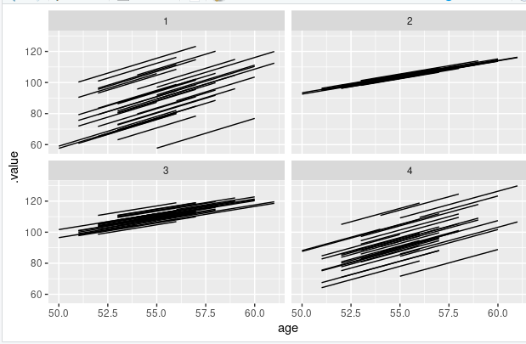

running %>%
+ add_predicted_draws(running_model_1_prior, n = 100) %>%
+ ggplot(aes(x = net)) +
+ geom_density(aes(x = .prediction, group = .draw)) +
+ xlim(-100,300)
Warning messages:
1:
In add_predicted_draws(): The `n` argument is a deprecated alias for `ndraws`.
Use the `ndraws` argument instead.
See help("tidybayes-deprecated").

2: Removed 70 rows containing non-finite outside the scale range (`stat_density()`).

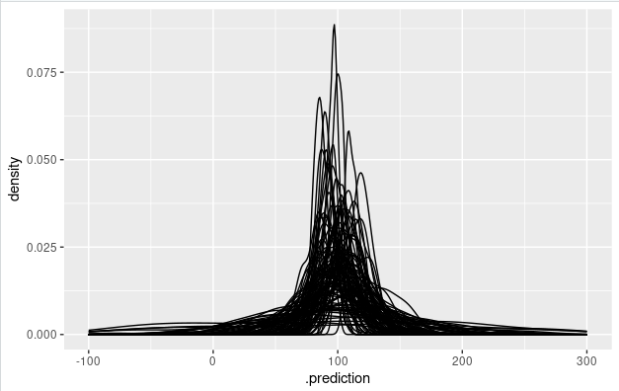

> ggplot(running, aes(x = age, y = net)) +
+ geom_point() +
+ facet_wrap(~ runner)

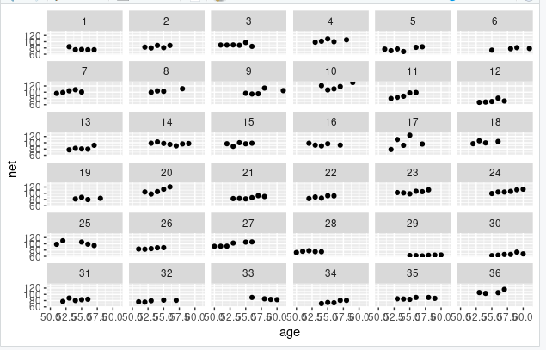

# Simulate the posterior
> running_model_1 <- update(running_model_1_prior, prior_PD = FALSE)

SAMPLING FOR MODEL 'continuous' NOW (CHAIN 1).
Chain 1:
Chain 1: Gradient evaluation took 0.000626 seconds
Chain 1: 1000 transitions using 10 leapfrog steps per transition would take 6.26 seconds.
Chain 1: Adjust your expectations accordingly!
Chain 1:
Chain 1:
Chain 1: Iteration: 1 / 10000 [ 0%] (Warmup)
Chain 1: Iteration: 1000 / 10000 [ 10%] (Warmup)
Chain 1: Iteration: 2000 / 10000 [ 20%] (Warmup)
Chain 1: Iteration: 3000 / 10000 [ 30%] (Warmup)
Chain 1: Iteration: 4000 / 10000 [ 40%] (Warmup)
Chain 1: Iteration: 5000 / 10000 [ 50%] (Warmup)
Chain 1: Iteration: 5001 / 10000 [ 50%] (Sampling)
Chain 1: Iteration: 6000 / 10000 [ 60%] (Sampling)
Chain 1: Iteration: 7000 / 10000 [ 70%] (Sampling)
Chain 1: Iteration: 8000 / 10000 [ 80%] (Sampling)
Chain 1: Iteration: 9000 / 10000 [ 90%] (Sampling)
Chain 1: Iteration: 10000 / 10000 [100%] (Sampling)
Chain 1:
Chain 1: Elapsed Time: 4.71581 seconds (Warm-up)
Chain 1: 3.93769 seconds (Sampling)
Chain 1: 8.6535 seconds (Total)
Chain 1:

SAMPLING FOR MODEL 'continuous' NOW (CHAIN 2).
Chain 2:
Chain 2: Gradient evaluation took 4.6e-05 seconds
Chain 2: 1000 transitions using 10 leapfrog steps per transition would take 0.46 seconds.
Chain 2: Adjust your expectations accordingly!
Chain 2:
Chain 2:
Chain 2: Iteration: 1 / 10000 [ 0%] (Warmup)
Chain 2: Iteration: 1000 / 10000 [ 10%] (Warmup)
Chain 2: Iteration: 2000 / 10000 [ 20%] (Warmup)
Chain 2: Iteration: 3000 / 10000 [ 30%] (Warmup)
Chain 2: Iteration: 4000 / 10000 [ 40%] (Warmup)
Chain 2: Iteration: 5000 / 10000 [ 50%] (Warmup)
Chain 2: Iteration: 5001 / 10000 [ 50%] (Sampling)
Chain 2: Iteration: 6000 / 10000 [ 60%] (Sampling)
Chain 2: Iteration: 7000 / 10000 [ 70%] (Sampling)
Chain 2: Iteration: 8000 / 10000 [ 80%] (Sampling)
Chain 2: Iteration: 9000 / 10000 [ 90%] (Sampling)
Chain 2: Iteration: 10000 / 10000 [100%] (Sampling)
Chain 2:
Chain 2: Elapsed Time: 4.14958 seconds (Warm-up)
Chain 2: 3.9946 seconds (Sampling)
Chain 2: 8.14419 seconds (Total)
Chain 2:

SAMPLING FOR MODEL 'continuous' NOW (CHAIN 3).
Chain 3:
Chain 3: Gradient evaluation took 5.5e-05 seconds
Chain 3: 1000 transitions using 10 leapfrog steps per transition would take 0.55 seconds.
Chain 3: Adjust your expectations accordingly!
Chain 3:
Chain 3:
Chain 3: Iteration: 1 / 10000 [ 0%] (Warmup)
Chain 3: Iteration: 1000 / 10000 [ 10%] (Warmup)
Chain 3: Iteration: 2000 / 10000 [ 20%] (Warmup)
Chain 3: Iteration: 3000 / 10000 [ 30%] (Warmup)
Chain 3: Iteration: 4000 / 10000 [ 40%] (Warmup)
Chain 3: Iteration: 5000 / 10000 [ 50%] (Warmup)
Chain 3: Iteration: 5001 / 10000 [ 50%] (Sampling)
Chain 3: Iteration: 6000 / 10000 [ 60%] (Sampling)
Chain 3: Iteration: 7000 / 10000 [ 70%] (Sampling)
Chain 3: Iteration: 8000 / 10000 [ 80%] (Sampling)
Chain 3: Iteration: 9000 / 10000 [ 90%] (Sampling)
Chain 3: Iteration: 10000 / 10000 [100%] (Sampling)
Chain 3:
Chain 3: Elapsed Time: 4.33728 seconds (Warm-up)
Chain 3: 3.47387 seconds (Sampling)
Chain 3: 7.81115 seconds (Total)
Chain 3:

SAMPLING FOR MODEL 'continuous' NOW (CHAIN 4).
Chain 4:
Chain 4: Gradient evaluation took 7.7e-05 seconds
Chain 4: 1000 transitions using 10 leapfrog steps per transition would take 0.77 seconds.
Chain 4: Adjust your expectations accordingly!
Chain 4:
Chain 4:
Chain 4: Iteration: 1 / 10000 [ 0%] (Warmup)
Chain 4: Iteration: 1000 / 10000 [ 10%] (Warmup)
Chain 4: Iteration: 2000 / 10000 [ 20%] (Warmup)
Chain 4: Iteration: 3000 / 10000 [ 30%] (Warmup)
Chain 4: Iteration: 4000 / 10000 [ 40%] (Warmup)
Chain 4: Iteration: 5000 / 10000 [ 50%] (Warmup)
Chain 4: Iteration: 5001 / 10000 [ 50%] (Sampling)
Chain 4: Iteration: 6000 / 10000 [ 60%] (Sampling)
Chain 4: Iteration: 7000 / 10000 [ 70%] (Sampling)
Chain 4: Iteration: 8000 / 10000 [ 80%] (Sampling)
Chain 4: Iteration: 9000 / 10000 [ 90%] (Sampling)
Chain 4: Iteration: 10000 / 10000 [100%] (Sampling)
Chain 4:
Chain 4: Elapsed Time: 3.95087 seconds (Warm-up)
Chain 4: 3.53202 seconds (Sampling)
Chain 4: 7.4829 seconds (Total)
Chain 4:
> # Check the prior specifications
> prior_summary(running_model_1)
Priors for model 'running_model_1'
------
Intercept (after predictors centered)
~ normal(location = 100, scale = 10)

Coefficients
~ normal(location = 2.5, scale = 1)

Auxiliary (sigma)
Specified prior:
~ exponential(rate = 1)
Adjusted prior:
~ exponential(rate = 0.072)

Covariance
~ decov(reg. = 1, conc. = 1, shape = 1, scale = 1)
------
See help('prior_summary.stanreg') for more details

# Markov chain diagnostics
> mcmc_trace(running_model_1)
>

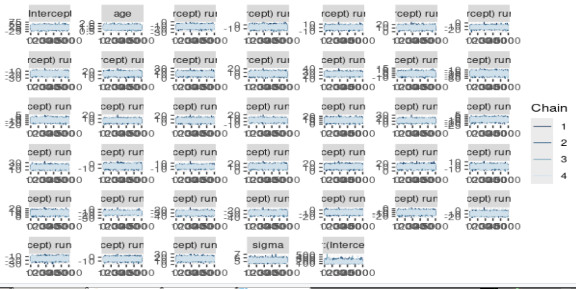

mcmc_dens_overlay(running_model_1)

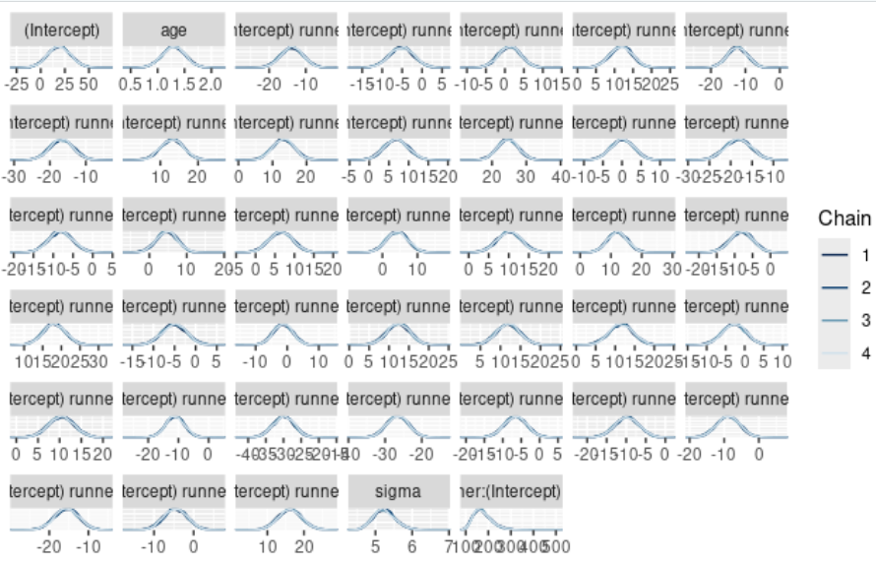
mcmc_acf(running_model_1)
Error:
! The `facets` argument of `facet_grid()` was deprecated in ggplot2 2.2.0
and is now defunct.
ℹ Please use the `rows` argument instead.
neff_ratio(running_model_1)
(Intercept) age
0.55410 0.67660
b[(Intercept) runner:1] b[(Intercept) runner:2]
0.14430 0.13960
b[(Intercept) runner:3] b[(Intercept) runner:4]
0.13110 0.14270
b[(Intercept) runner:5] b[(Intercept) runner:6]
0.13595 0.17235
b[(Intercept) runner:7] b[(Intercept) runner:8]
0.14715 0.17260
b[(Intercept) runner:9] b[(Intercept) runner:10]
0.14295 0.14795
b[(Intercept) runner:11] b[(Intercept) runner:12]
0.14525 0.14415
b[(Intercept) runner:13] b[(Intercept) runner:14]
0.13935 0.12480
b[(Intercept) runner:15] b[(Intercept) runner:16]
0.14905 0.14640
b[(Intercept) runner:17] b[(Intercept) runner:18]
0.14160 0.16400
b[(Intercept) runner:19] b[(Intercept) runner:20]
0.15825 0.15335
b[(Intercept) runner:21] b[(Intercept) runner:22]
0.13020 0.13700
b[(Intercept) runner:23] b[(Intercept) runner:24]
0.13235 0.13515
b[(Intercept) runner:25] b[(Intercept) runner:26]
0.14010 0.14580
b[(Intercept) runner:27] b[(Intercept) runner:28]
0.13045 0.14090
b[(Intercept) runner:29] b[(Intercept) runner:30]
0.14240 0.13640
b[(Intercept) runner:31] b[(Intercept) runner:32]
0.15175 0.13595
b[(Intercept) runner:33] b[(Intercept) runner:34]
0.16375 0.14645
b[(Intercept) runner:35] b[(Intercept) runner:36]
0.13310 0.16540
sigma Sigma[runner:(Intercept),(Intercept)]
0.58175 0.11945
rhat(running_model_1)
(Intercept) age
0.9999078 1.0000822
b[(Intercept) runner:1] b[(Intercept) runner:2]
1.0015132 1.0014094
b[(Intercept) runner:3] b[(Intercept) runner:4]
1.0014783 1.0017772
b[(Intercept) runner:5] b[(Intercept) runner:6]
1.0013959 1.0016164
b[(Intercept) runner:7] b[(Intercept) runner:8]
1.0012433 1.0014755
b[(Intercept) runner:9] b[(Intercept) runner:10]
1.0020477 1.0014785
b[(Intercept) runner:11] b[(Intercept) runner:12]
1.0012548 1.0016712
b[(Intercept) runner:13] b[(Intercept) runner:14]
1.0018422 1.0018428
b[(Intercept) runner:15] b[(Intercept) runner:16]
1.0011314 1.0020097
b[(Intercept) runner:17] b[(Intercept) runner:18]
1.0015128 1.0012979
b[(Intercept) runner:19] b[(Intercept) runner:20]
1.0017958 1.0016313
b[(Intercept) runner:21] b[(Intercept) runner:22]
1.0019209 1.0016589
b[(Intercept) runner:23] b[(Intercept) runner:24]
1.0021513 1.0017771
b[(Intercept) runner:25] b[(Intercept) runner:26]
1.0016446 1.0013913
b[(Intercept) runner:27] b[(Intercept) runner:28]
1.0012927 1.0007219
b[(Intercept) runner:29] b[(Intercept) runner:30]
1.0021876 1.0017164
b[(Intercept) runner:31] b[(Intercept) runner:32]
1.0014211 1.0012527
b[(Intercept) runner:33] b[(Intercept) runner:34]
1.0013874 1.0015324
b[(Intercept) runner:35] b[(Intercept) runner:36]
1.0019749 1.0014164
sigma Sigma[runner:(Intercept),(Intercept)]
0.9999635 1.0000126
tidy_summary_1 <- tidy(running_model_1, effects = "fixed",
+ conf.int = TRUE, conf.level = 0.80)
> tidy_summary_1
# A tibble: 2 × 5
term estimate std.error conf.low conf.high
<chr> <dbl> <dbl> <dbl> <dbl>
1 (Intercept) 19.1 12.2 3.74 34.7
2 age 1.30 0.217 1.02 1.58
> B0 <- tidy_summary_1$estimate[1]
> B1 <- tidy_summary_1$estimate[2]
> running %>%
+ add_fitted_draws(running_model_1, n = 200, re_formula = NA) %>%
+ ggplot(aes(x = age, y = net)) +
+ geom_line(aes(y = .value, group = .draw), alpha = 0.1) +
+ geom_abline(intercept = B0, slope = B1, color = "blue") +
+ lims(y = c(75, 110))
Warning messages:
1: `fitted_draws` and `add_fitted_draws` are deprecated as their names were confusing.
- Use [add_]epred_draws() to get the expectation of the posterior predictive.
- Use [add_]linpred_draws() to get the distribution of the linear predictor.
- For example, you used [add_]fitted_draws(..., scale = "response"), which
means you most likely want [add_]epred_draws(...).
NOTE: When updating to the new functions, note that the `model` parameter is now
named `object` and the `n` parameter is now named `ndraws`.
2: Removed 2 rows containing missing values or values outside the scale range
(`geom_line()`).

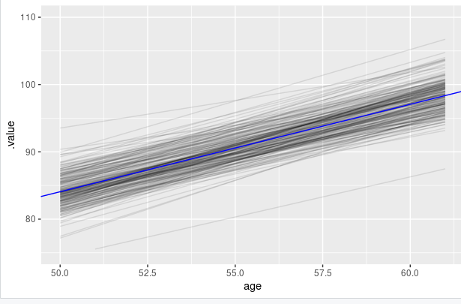
runner_summaries_1 <- running_model_1 %>%
+ spread_draws(`(Intercept)`, b[,runner]) %>%
+ mutate(runner_intercept = `(Intercept)` + b) %>%
+ select(-`(Intercept)`, -b) %>%
+ median_qi(.width = 0.80) %>%
+ select(runner, runner_intercept, .lower, .upper)
> runner_summaries_1 %>%
+ filter(runner %in% c("runner:4", "runner:5"))
# A tibble: 2 × 4
runner runner_intercept .lower .upper
<chr> <dbl> <dbl> <dbl>
1 runner:4 30.9 15.4 46.7
2 runner:5 6.73 -8.30 22.2
> # 100 posterior plausible models for runners 4 & 5
> running %>%
+ filter(runner %in% c("4", "5")) %>%
+ add_fitted_draws(running_model_1, n = 100) %>%
+ ggplot(aes(x = age, y = net)) +
+ geom_line(
+ aes(y = .value, group = paste(runner, .draw), color = runner),
+ alpha = 0.1) +
+ geom_point(aes(color = runner))
Warning message:
`fitted_draws` and `add_fitted_draws` are deprecated as their names were confusing.
- Use [add_]epred_draws() to get the expectation of the posterior predictive.
- Use [add_]linpred_draws() to get the distribution of the linear predictor.
- For example, you used [add_]fitted_draws(..., scale = "response"), which
means you most likely want [add_]epred_draws(...).
NOTE: When updating to the new functions, note that the `model` parameter is now
named `object` and the `n` parameter is now named `ndraws`.

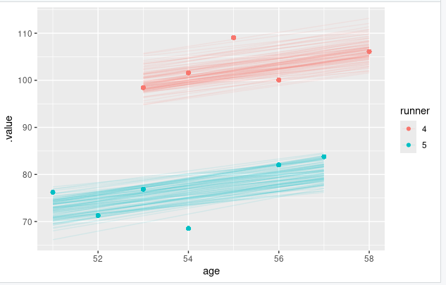

# Plot runner-specific models with the global model
> ggplot(running, aes(y = net, x = age, group = runner)) +
+ geom_abline(data = runner_summaries_1, color = "gray",
+ aes(intercept = runner_intercept, slope = B1)) +
+ geom_abline(intercept = B0, slope = B1, color = "blue") +
+ lims(x = c(50, 61), y = c(50, 135))

tidy_sigma <- tidy(running_model_1, effects = "ran_pars")
> tidy_sigma
# A tibble: 2 × 3
term group estimate
<chr> <chr> <dbl>
1 sd_(Intercept).runner runner 13.3
2 sd_Observation.Residual Residual 5.25
> sigma_0 <- tidy_sigma[1,3]
> sigma_y <- tidy_sigma[2,3]
> sigma_0^2 / (sigma_0^2 + sigma_y^2)
estimate
1 0.865279
>
> sigma_y^2 / (sigma_0^2 + sigma_y^2)
estimate
1 0.134721
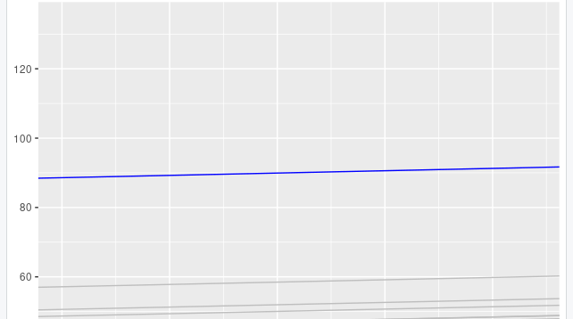
> #17.3
>
> # Plot runner-specific models in the data
> running %>%
+ filter(runner %in% c("4", "5", "20", "29")) %>%
+ ggplot(., aes(x = age, y = net)) +
+ geom_point() +
+ geom_smooth(method = "lm", se = FALSE) +
+ facet_grid(~ runner)
`geom_smooth()` using formula = 'y ~ x'

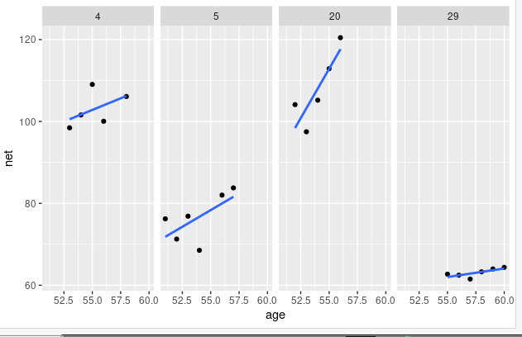
> ggplot(running, aes(x = age, y = net, group = runner)) +
+ geom_smooth(method = "lm", se = FALSE, size = 0.5)
`geom_smooth()` using formula = 'y ~ x'
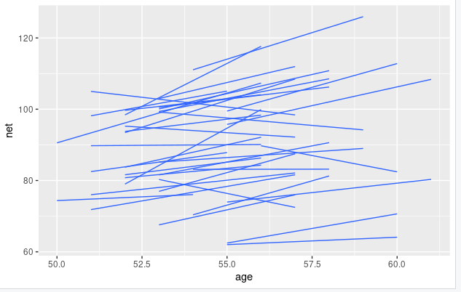

running_model_2 <- stan_glmer(
+ net ~ age + (age | runner),
+ data = running, family = gaussian,
+ prior_intercept = normal(100, 10),
+ prior = normal(2.5, 1),
+ prior_aux = exponential(1, autoscale = TRUE),
+ prior_covariance = decov(reg = 1, conc = 1, shape = 1, scale = 1),
+ chains = 4, iter = 5000*2, seed = 84735, adapt_delta = 0.99999
+ )

SAMPLING FOR MODEL 'continuous' NOW (CHAIN 1).
Chain 1:
Chain 1: Gradient evaluation took 0.000214 seconds
Chain 1: 1000 transitions using 10 leapfrog steps per transition would take 2.14 seconds.
Chain 1: Adjust your expectations accordingly!
Chain 1:
Chain 1:
Chain 1: Iteration: 1 / 10000 [ 0%] (Warmup)
Chain 1: Iteration: 1000 / 10000 [ 10%] (Warmup)
Chain 1: Iteration: 2000 / 10000 [ 20%] (Warmup)
Chain 1: Iteration: 3000 / 10000 [ 30%] (Warmup)
Chain 1: Iteration: 4000 / 10000 [ 40%] (Warmup)
Chain 1: Iteration: 5000 / 10000 [ 50%] (Warmup)
Chain 1: Iteration: 5001 / 10000 [ 50%] (Sampling)
Chain 1: Iteration: 6000 / 10000 [ 60%] (Sampling)
Chain 1: Iteration: 7000 / 10000 [ 70%] (Sampling)
Chain 1: Iteration: 8000 / 10000 [ 80%] (Sampling)
Chain 1: Iteration: 9000 / 10000 [ 90%] (Sampling)
Chain 1: Iteration: 10000 / 10000 [100%] (Sampling)
Chain 1:
Chain 1: Elapsed Time: 317.753 seconds (Warm-up)
Chain 1: 388.056 seconds (Sampling)
Chain 1: 705.809 seconds (Total)
Chain 1:

SAMPLING FOR MODEL 'continuous' NOW (CHAIN 2).
Chain 2:
Chain 2: Gradient evaluation took 0.000184 seconds
Chain 2: 1000 transitions using 10 leapfrog steps per transition would take 1.84 seconds.
Chain 2: Adjust your expectations accordingly!
Chain 2:
Chain 2:
Chain 2: Iteration: 1 / 10000 [ 0%] (Warmup)
Chain 2: Iteration: 1000 / 10000 [ 10%] (Warmup)
Chain 2: Iteration: 2000 / 10000 [ 20%] (Warmup)
Chain 2: Iteration: 3000 / 10000 [ 30%] (Warmup)
Chain 2: Iteration: 4000 / 10000 [ 40%] (Warmup)
Chain 2: Iteration: 5000 / 10000 [ 50%] (Warmup)
Chain 2: Iteration: 5001 / 10000 [ 50%] (Sampling)
Chain 2: Iteration: 6000 / 10000 [ 60%] (Sampling)
Chain 2: Iteration: 7000 / 10000 [ 70%] (Sampling)
Chain 2: Iteration: 8000 / 10000 [ 80%] (Sampling)
Chain 2: Iteration: 9000 / 10000 [ 90%] (Sampling)
Chain 2: Iteration: 10000 / 10000 [100%] (Sampling)
Chain 2:
Chain 2: Elapsed Time: 321.413 seconds (Warm-up)
Chain 2: 245.469 seconds (Sampling)
Chain 2: 566.882 seconds (Total)
Chain 2:

SAMPLING FOR MODEL 'continuous' NOW (CHAIN 3).
Chain 3:
Chain 3: Gradient evaluation took 0.000107 seconds
Chain 3: 1000 transitions using 10 leapfrog steps per transition would take 1.07 seconds.
Chain 3: Adjust your expectations accordingly!
Chain 3:
Chain 3:
Chain 3: Iteration: 1 / 10000 [ 0%] (Warmup)
Chain 3: Iteration: 1000 / 10000 [ 10%] (Warmup)
Chain 3: Iteration: 2000 / 10000 [ 20%] (Warmup)
Chain 3: Iteration: 3000 / 10000 [ 30%] (Warmup)
Chain 3: Iteration: 4000 / 10000 [ 40%] (Warmup)
Chain 3: Iteration: 5000 / 10000 [ 50%] (Warmup)
Chain 3: Iteration: 5001 / 10000 [ 50%] (Sampling)
Chain 3: Iteration: 6000 / 10000 [ 60%] (Sampling)
Chain 3: Iteration: 7000 / 10000 [ 70%] (Sampling)
Chain 3: Iteration: 8000 / 10000 [ 80%] (Sampling)
Chain 3: Iteration: 9000 / 10000 [ 90%] (Sampling)
Chain 3: Iteration: 10000 / 10000 [100%] (Sampling)
Chain 3:
Chain 3: Elapsed Time: 349.419 seconds (Warm-up)
Chain 3: 339.229 seconds (Sampling)
Chain 3: 688.648 seconds (Total)
Chain 3:

SAMPLING FOR MODEL 'continuous' NOW (CHAIN 4).
Chain 4:
Chain 4: Gradient evaluation took 0.000105 seconds
Chain 4: 1000 transitions using 10 leapfrog steps per transition would take 1.05 seconds.
Chain 4: Adjust your expectations accordingly!
Chain 4:
Chain 4:
Chain 4: Iteration: 1 / 10000 [ 0%] (Warmup)
Chain 4: Iteration: 1000 / 10000 [ 10%] (Warmup)
Chain 4: Iteration: 2000 / 10000 [ 20%] (Warmup)
Chain 4: Iteration: 3000 / 10000 [ 30%] (Warmup)
Chain 4: Iteration: 4000 / 10000 [ 40%] (Warmup)
Chain 4: Iteration: 5000 / 10000 [ 50%] (Warmup)
Chain 4: Iteration: 5001 / 10000 [ 50%] (Sampling)
Chain 4: Iteration: 6000 / 10000 [ 60%] (Sampling)
Chain 4: Iteration: 7000 / 10000 [ 70%] (Sampling)
Chain 4: Iteration: 8000 / 10000 [ 80%] (Sampling)
Chain 4: Iteration: 9000 / 10000 [ 90%] (Sampling)
Chain 4: Iteration: 10000 / 10000 [100%] (Sampling)
Chain 4:
Chain 4: Elapsed Time: 317.725 seconds (Warm-up)
Chain 4: 398.924 seconds (Sampling)
Chain 4: 716.648 seconds (Total)
Chain 4:

# Confirm the prior model specifications
> prior_summary(running_model_2)
Priors for model 'running_model_2'
------
Intercept (after predictors centered)
~ normal(location = 100, scale = 10)

Coefficients
~ normal(location = 2.5, scale = 1)

Auxiliary (sigma)
Specified prior:
~ exponential(rate = 1)
Adjusted prior:
~ exponential(rate = 0.072)

Covariance
~ decov(reg. = 1, conc. = 1, shape = 1, scale = 1)
------
See help('prior_summary.stanreg') for more details
> # Quick summary of global regression parameters
> tidy(running_model_2, effects = "fixed", conf.int = TRUE, conf.level = 0.80)
# A tibble: 2 × 5
term estimate std.error conf.low conf.high
<chr> <dbl> <dbl> <dbl> <dbl>
1 (Intercept) 18.5 11.6 3.36 33.6
2 age 1.32 0.215 1.04 1.59
> # Get MCMC chains for the runner-specific intercepts & slopes
> runner_chains_2 <- running_model_2 %>%
+ spread_draws(`(Intercept)`, b[term, runner], `age`) %>%
+ pivot_wider(names_from = term, names_glue = "b_{term}",
+ values_from = b) %>%
+ mutate(runner_intercept = `(Intercept)` + `b_(Intercept)`,
+ runner_age = age + b_age)
# Posterior medians of runner-specific models
> runner_summaries_2 <- runner_chains_2 %>%
+ group_by(runner) %>%
+ summarize(runner_intercept = median(runner_intercept),
+ runner_age = median(runner_age))
> # Check it out
> head(runner_summaries_2, 3)
# A tibble: 3 × 3
runner runner_intercept runner_age
<chr> <dbl> <dbl>
1 runner:1 18.5 1.06
2 runner:10 18.5 1.75
3 runner:11 18.4 1.32
> ggplot(running, aes(y = net, x = age, group = runner)) +
+ geom_abline(data = runner_summaries_2, color = "gray",
+ aes(intercept = runner_intercept, slope = runner_age)) +
+ lims(x = c(50, 61), y = c(50, 135))
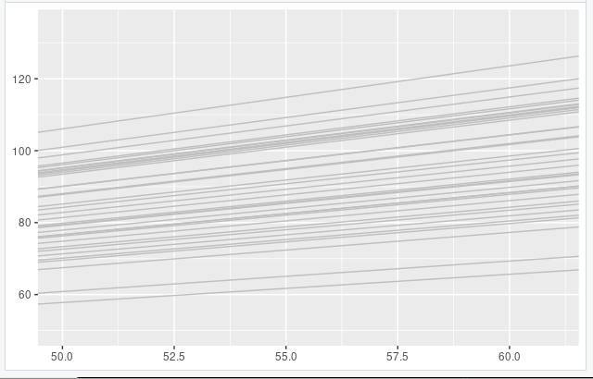

runner_summaries_2 %>%
+ filter(runner %in% c("runner:1", "runner:10"))
# A tibble: 2 × 3
runner runner_intercept runner_age
<chr> <dbl> <dbl>
1 runner:1 18.5 1.06
2 runner:10 18.5 1.75
> tidy(running_model_2, effects = "ran_pars")
# A tibble: 4 × 3
term group estimate
<chr> <chr> <dbl>
1 sd_(Intercept).runner runner 1.31
2 sd_age.runner runner 0.251
3 cor_(Intercept).age.runner runner -0.0946
4 sd_Observation.Residual Residual 5.16

> pp_check(complete_pooled_model) +
+ labs(x = "net", title = "complete pooled model")

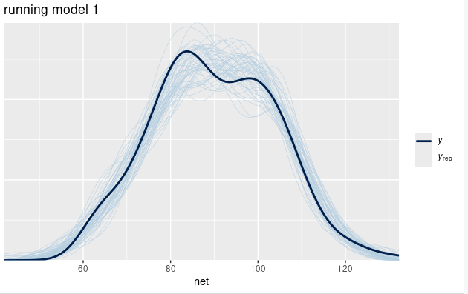

pp_check(running_model_1) +
+ labs(x = "net", title = "running model 1")

> pp_check(running_model_2) +
+ labs(x = "net", title = "running model 2")

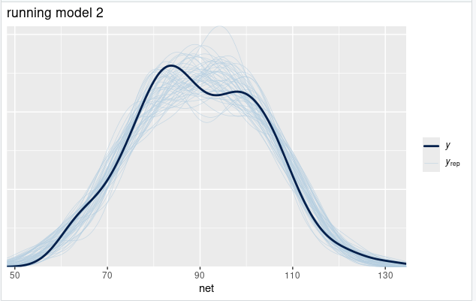

set.seed(84735)
> prediction_summary(model = running_model_1, data = running)
mae mae_scaled within_50 within_95
1 2.614707 0.4559292 0.6918919 0.972973
> prediction_summary(model = running_model_2, data = running)
mae mae_scaled within_50 within_95
1 2.540835 0.4447402 0.7135135 0.972973
> prediction_summary_cv(model = running_model_1, data = running,
+ k = 10, group = "runner")
$folds
fold mae mae_scaled within_50 within_95
1 1 12.247407 0.8437279 0.2142857 1.0000000
2 2 10.234951 0.7083522 0.4736842 0.8947368
3 3 6.641207 0.4538991 0.6428571 1.0000000
4 4 8.593234 0.5830889 0.5217391 1.0000000
5 5 9.819427 0.6927232 0.5000000 0.7272727
6 6 19.308510 1.4081746 0.1250000 0.6250000
7 7 14.126170 0.9654740 0.2631579 1.0000000
8 8 5.912343 0.3964774 0.6470588 1.0000000
9 9 12.433554 0.8615853 0.4090909 0.9545455
10 10 6.570708 0.4376038 0.6315789 1.0000000

$cv
mae mae_scaled within_50 within_95
1 10.58875 0.7351106 0.4428453 0.9201555

#Calculate ELPD for the 2 models
> elpd_hierarchical_1 <- loo(running_model_1)
Warning message:
Found 2 observation(s) with a pareto_k > 0.7. We recommend calling 'loo' again with argument 'k_threshold = 0.7' in order to calculate the ELPD without the assumption that these observations are negligible. This will refit the model 2 times to compute the ELPDs for the problematic observations directly.

> elpd_hierarchical_2 <- loo(running_model_2)
Warning message:
Found 2 observation(s) with a pareto_k > 0.7. We recommend calling 'loo' again with argument 'k_threshold = 0.7' in order to calculate the ELPD without the assumption that these observations are negligible. This will refit the model 2 times to compute the ELPDs for the problematic observations directly.

> # Compare the ELPD
> loo_compare(elpd_hierarchical_1, elpd_hierarchical_2)
elpd_diff se_diff
running_model_2 0.0 0.0
running_model_1 -1.6 1.2

# Plot runner-specific trends for runners 1 & 10
> running %>%
+ filter(runner %in% c("1", "10")) %>%
+ ggplot(., aes(x = age, y = net)) +
+ geom_point() +
+ facet_grid(~ runner) +
+ lims(x = c(54, 61))
Warning message:
Removed 1 row containing missing values or values outside the scale range
(`geom_point()`).

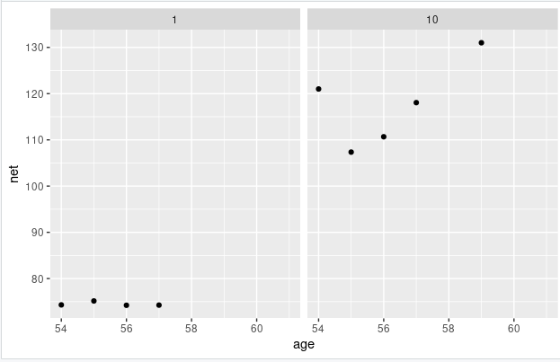

# Simulate posterior predictive models for the 3 runners
> set.seed(84735)
> predict_next_race <- posterior_predict(
+ running_model_1,
+ newdata = data.frame(runner = c("1", "Miles", "10"),
+ age = c(61, 61, 61)))
> B0 + B1 * 61
[1] 98.36634
>
>
> # Posterior predictive model plots
> mcmc_areas(predict_next_race, prob = 0.8) +
+ ggplot2::scale_y_discrete(labels = c("runner 1", "Miles", "runner 10"))
Scale for y is already present.
Adding another scale for y, which will replace the existing scale.

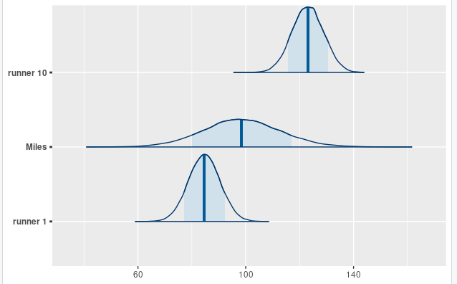

# Import and wrangle the data
> data(spotify)
> spotify <- spotify %>%
+ select(artist, title, danceability, valence, genre)
> ggplot(spotify, aes(y = danceability, x = genre)) +
+ geom_boxplot()

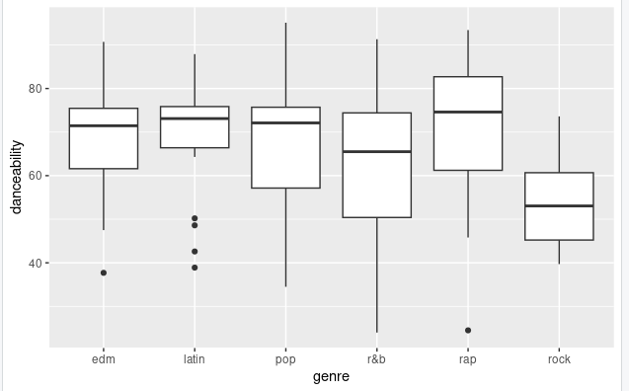

> ggplot(spotify, aes(y = danceability, x = valence)) +
+ geom_point()
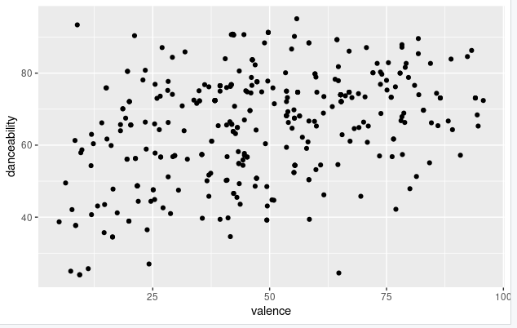

> ggplot(spotify, aes(y = danceability, x = valence, group = artist)) +
+ geom_smooth(method = "lm", se = FALSE, size = 0.5)
`geom_smooth()` using formula = 'y ~ x'
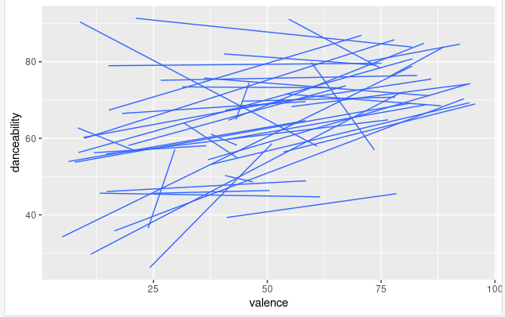

spotify_model_1 <- stan_glmer(
+ danceability ~ valence + genre + (1 | artist),
+ data = spotify, family = gaussian,
+ prior_intercept = normal(50, 2.5, autoscale = TRUE),
+ prior = normal(0, 2.5, autoscale = TRUE),
+ prior_aux = exponential(1, autoscale = TRUE),
+ prior_covariance = decov(reg = 1, conc = 1, shape = 1, scale = 1),
+ chains = 4, iter = 5000*2, seed = 84735)

SAMPLING FOR MODEL 'continuous' NOW (CHAIN 1).
Chain 1:
Chain 1: Gradient evaluation took 7.5e-05 seconds
Chain 1: 1000 transitions using 10 leapfrog steps per transition would take 0.75 seconds.
Chain 1: Adjust your expectations accordingly!
Chain 1:
Chain 1:
Chain 1: Iteration: 1 / 10000 [ 0%] (Warmup)
Chain 1: Iteration: 1000 / 10000 [ 10%] (Warmup)
Chain 1: Iteration: 2000 / 10000 [ 20%] (Warmup)
Chain 1: Iteration: 3000 / 10000 [ 30%] (Warmup)
Chain 1: Iteration: 4000 / 10000 [ 40%] (Warmup)
Chain 1: Iteration: 5000 / 10000 [ 50%] (Warmup)
Chain 1: Iteration: 5001 / 10000 [ 50%] (Sampling)
Chain 1: Iteration: 6000 / 10000 [ 60%] (Sampling)
Chain 1: Iteration: 7000 / 10000 [ 70%] (Sampling)
Chain 1: Iteration: 8000 / 10000 [ 80%] (Sampling)
Chain 1: Iteration: 9000 / 10000 [ 90%] (Sampling)
Chain 1: Iteration: 10000 / 10000 [100%] (Sampling)
Chain 1:
Chain 1: Elapsed Time: 5.48905 seconds (Warm-up)
Chain 1: 7.53802 seconds (Sampling)
Chain 1: 13.0271 seconds (Total)
Chain 1:

SAMPLING FOR MODEL 'continuous' NOW (CHAIN 2).
Chain 2:
Chain 2: Gradient evaluation took 8.4e-05 seconds
Chain 2: 1000 transitions using 10 leapfrog steps per transition would take 0.84 seconds.
Chain 2: Adjust your expectations accordingly!
Chain 2:
Chain 2:
Chain 2: Iteration: 1 / 10000 [ 0%] (Warmup)
Chain 2: Iteration: 1000 / 10000 [ 10%] (Warmup)
Chain 2: Iteration: 2000 / 10000 [ 20%] (Warmup)
Chain 2: Iteration: 3000 / 10000 [ 30%] (Warmup)
Chain 2: Iteration: 4000 / 10000 [ 40%] (Warmup)
Chain 2: Iteration: 5000 / 10000 [ 50%] (Warmup)
Chain 2: Iteration: 5001 / 10000 [ 50%] (Sampling)
Chain 2: Iteration: 6000 / 10000 [ 60%] (Sampling)
Chain 2: Iteration: 7000 / 10000 [ 70%] (Sampling)
Chain 2: Iteration: 8000 / 10000 [ 80%] (Sampling)
Chain 2: Iteration: 9000 / 10000 [ 90%] (Sampling)
Chain 2: Iteration: 10000 / 10000 [100%] (Sampling)
Chain 2:
Chain 2: Elapsed Time: 5.83457 seconds (Warm-up)
Chain 2: 5.31674 seconds (Sampling)
Chain 2: 11.1513 seconds (Total)
Chain 2:

SAMPLING FOR MODEL 'continuous' NOW (CHAIN 3).
Chain 3:
Chain 3: Gradient evaluation took 6e-05 seconds
Chain 3: 1000 transitions using 10 leapfrog steps per transition would take 0.6 seconds.
Chain 3: Adjust your expectations accordingly!
Chain 3:
Chain 3:
Chain 3: Iteration: 1 / 10000 [ 0%] (Warmup)
Chain 3: Iteration: 1000 / 10000 [ 10%] (Warmup)
Chain 3: Iteration: 2000 / 10000 [ 20%] (Warmup)
Chain 3: Iteration: 3000 / 10000 [ 30%] (Warmup)
Chain 3: Iteration: 4000 / 10000 [ 40%] (Warmup)
Chain 3: Iteration: 5000 / 10000 [ 50%] (Warmup)
Chain 3: Iteration: 5001 / 10000 [ 50%] (Sampling)
Chain 3: Iteration: 6000 / 10000 [ 60%] (Sampling)
Chain 3: Iteration: 7000 / 10000 [ 70%] (Sampling)
Chain 3: Iteration: 8000 / 10000 [ 80%] (Sampling)
Chain 3: Iteration: 9000 / 10000 [ 90%] (Sampling)
Chain 3: Iteration: 10000 / 10000 [100%] (Sampling)
Chain 3:
Chain 3: Elapsed Time: 6.14761 seconds (Warm-up)
Chain 3: 4.08301 seconds (Sampling)
Chain 3: 10.2306 seconds (Total)
Chain 3:

SAMPLING FOR MODEL 'continuous' NOW (CHAIN 4).
Chain 4:
Chain 4: Gradient evaluation took 6.7e-05 seconds
Chain 4: 1000 transitions using 10 leapfrog steps per transition would take 0.67 seconds.
Chain 4: Adjust your expectations accordingly!
Chain 4:
Chain 4:
Chain 4: Iteration: 1 / 10000 [ 0%] (Warmup)
Chain 4: Iteration: 1000 / 10000 [ 10%] (Warmup)
Chain 4: Iteration: 2000 / 10000 [ 20%] (Warmup)
Chain 4: Iteration: 3000 / 10000 [ 30%] (Warmup)
Chain 4: Iteration: 4000 / 10000 [ 40%] (Warmup)
Chain 4: Iteration: 5000 / 10000 [ 50%] (Warmup)
Chain 4: Iteration: 5001 / 10000 [ 50%] (Sampling)
Chain 4: Iteration: 6000 / 10000 [ 60%] (Sampling)
Chain 4: Iteration: 7000 / 10000 [ 70%] (Sampling)
Chain 4: Iteration: 8000 / 10000 [ 80%] (Sampling)
Chain 4: Iteration: 9000 / 10000 [ 90%] (Sampling)
Chain 4: Iteration: 10000 / 10000 [100%] (Sampling)
Chain 4:
Chain 4: Elapsed Time: 5.36186 seconds (Warm-up)
Chain 4: 4.12739 seconds (Sampling)
Chain 4: 9.48925 seconds (Total)
Chain 4:

spotify_model_2 <- stan_glmer(
+ danceability ~ valence + genre + (valence | artist),
+ data = spotify, family = gaussian,
+ prior_intercept = normal(50, 2.5, autoscale = TRUE),
+ prior = normal(0, 2.5, autoscale = TRUE),
+ prior_aux = exponential(1, autoscale = TRUE),
+ prior_covariance = decov(reg = 1, conc = 1, shape = 1, scale = 1),
+ chains = 4, iter = 5000*2, seed = 84735)

SAMPLING FOR MODEL 'continuous' NOW (CHAIN 1).
Chain 1:
Chain 1: Gradient evaluation took 0.000163 seconds
Chain 1: 1000 transitions using 10 leapfrog steps per transition would take 1.63 seconds.
Chain 1: Adjust your expectations accordingly!
Chain 1:
Chain 1:
Chain 1: Iteration: 1 / 10000 [ 0%] (Warmup)
Chain 1: Iteration: 1000 / 10000 [ 10%] (Warmup)
Chain 1: Iteration: 2000 / 10000 [ 20%] (Warmup)
Chain 1: Iteration: 3000 / 10000 [ 30%] (Warmup)
Chain 1: Iteration: 4000 / 10000 [ 40%] (Warmup)
Chain 1: Iteration: 5000 / 10000 [ 50%] (Warmup)
Chain 1: Iteration: 5001 / 10000 [ 50%] (Sampling)
Chain 1: Iteration: 6000 / 10000 [ 60%] (Sampling)
Chain 1: Iteration: 7000 / 10000 [ 70%] (Sampling)
Chain 1: Iteration: 8000 / 10000 [ 80%] (Sampling)
Chain 1: Iteration: 9000 / 10000 [ 90%] (Sampling)
Chain 1: Iteration: 10000 / 10000 [100%] (Sampling)
Chain 1:
Chain 1: Elapsed Time: 35.0646 seconds (Warm-up)
Chain 1: 32.9454 seconds (Sampling)
Chain 1: 68.01 seconds (Total)
Chain 1:

SAMPLING FOR MODEL 'continuous' NOW (CHAIN 2).
Chain 2:
Chain 2: Gradient evaluation took 0.000163 seconds
Chain 2: 1000 transitions using 10 leapfrog steps per transition would take 1.63 seconds.
Chain 2: Adjust your expectations accordingly!
Chain 2:
Chain 2:
Chain 2: Iteration: 1 / 10000 [ 0%] (Warmup)
Chain 2: Iteration: 1000 / 10000 [ 10%] (Warmup)
Chain 2: Iteration: 2000 / 10000 [ 20%] (Warmup)
Chain 2: Iteration: 3000 / 10000 [ 30%] (Warmup)
Chain 2: Iteration: 4000 / 10000 [ 40%] (Warmup)
Chain 2: Iteration: 5000 / 10000 [ 50%] (Warmup)
Chain 2: Iteration: 5001 / 10000 [ 50%] (Sampling)
Chain 2: Iteration: 6000 / 10000 [ 60%] (Sampling)
Chain 2: Iteration: 7000 / 10000 [ 70%] (Sampling)
Chain 2: Iteration: 8000 / 10000 [ 80%] (Sampling)
Chain 2: Iteration: 9000 / 10000 [ 90%] (Sampling)
Chain 2: Iteration: 10000 / 10000 [100%] (Sampling)
Chain 2:
Chain 2: Elapsed Time: 37.5497 seconds (Warm-up)
Chain 2: 27.522 seconds (Sampling)
Chain 2: 65.0717 seconds (Total)
Chain 2:

SAMPLING FOR MODEL 'continuous' NOW (CHAIN 3).
Chain 3:
Chain 3: Gradient evaluation took 0.000225 seconds
Chain 3: 1000 transitions using 10 leapfrog steps per transition would take 2.25 seconds.
Chain 3: Adjust your expectations accordingly!
Chain 3:
Chain 3:
Chain 3: Iteration: 1 / 10000 [ 0%] (Warmup)
Chain 3: Iteration: 1000 / 10000 [ 10%] (Warmup)
Chain 3: Iteration: 2000 / 10000 [ 20%] (Warmup)
Chain 3: Iteration: 3000 / 10000 [ 30%] (Warmup)
Chain 3: Iteration: 4000 / 10000 [ 40%] (Warmup)
Chain 3: Iteration: 5000 / 10000 [ 50%] (Warmup)
Chain 3: Iteration: 5001 / 10000 [ 50%] (Sampling)
Chain 3: Iteration: 6000 / 10000 [ 60%] (Sampling)
Chain 3: Iteration: 7000 / 10000 [ 70%] (Sampling)
Chain 3: Iteration: 8000 / 10000 [ 80%] (Sampling)
Chain 3: Iteration: 9000 / 10000 [ 90%] (Sampling)
Chain 3: Iteration: 10000 / 10000 [100%] (Sampling)
Chain 3:
Chain 3: Elapsed Time: 37.014 seconds (Warm-up)
Chain 3: 40.9998 seconds (Sampling)
Chain 3: 78.0137 seconds (Total)
Chain 3:

SAMPLING FOR MODEL 'continuous' NOW (CHAIN 4).
Chain 4:
Chain 4: Gradient evaluation took 0.000161 seconds
Chain 4: 1000 transitions using 10 leapfrog steps per transition would take 1.61 seconds.
Chain 4: Adjust your expectations accordingly!
Chain 4:
Chain 4:
Chain 4: Iteration: 1 / 10000 [ 0%] (Warmup)
Chain 4: Iteration: 1000 / 10000 [ 10%] (Warmup)
Chain 4: Iteration: 2000 / 10000 [ 20%] (Warmup)
Chain 4: Iteration: 3000 / 10000 [ 30%] (Warmup)
Chain 4: Iteration: 4000 / 10000 [ 40%] (Warmup)
Chain 4: Iteration: 5000 / 10000 [ 50%] (Warmup)
Chain 4: Iteration: 5001 / 10000 [ 50%] (Sampling)
Chain 4: Iteration: 6000 / 10000 [ 60%] (Sampling)
Chain 4: Iteration: 7000 / 10000 [ 70%] (Sampling)
Chain 4: Iteration: 8000 / 10000 [ 80%] (Sampling)
Chain 4: Iteration: 9000 / 10000 [ 90%] (Sampling)
Chain 4: Iteration: 10000 / 10000 [100%] (Sampling)
Chain 4:
Chain 4: Elapsed Time: 34.9622 seconds (Warm-up)
Chain 4: 40.6573 seconds (Sampling)
Chain 4: 75.6195 seconds (Total)
Chain 4:
# Check out the prior specifications
> prior_summary(spotify_model_1)
Priors for model 'spotify_model_1'
------
Intercept (after predictors centered)
Specified prior:
~ normal(location = 50, scale = 2.5)
Adjusted prior:
~ normal(location = 50, scale = 37)

Coefficients
Specified prior:
~ normal(location = [0,0,0,...], scale = [2.5,2.5,2.5,...])
Adjusted prior:
~ normal(location = [0,0,0,...], scale = [ 1.71,138.94, 92.19,...])

Auxiliary (sigma)
Specified prior:
~ exponential(rate = 1)
Adjusted prior:
~ exponential(rate = 0.067)

Covariance
~ decov(reg. = 1, conc. = 1, shape = 1, scale = 1)
------
See help('prior_summary.stanreg') for more details
> prior_summary(spotify_model_2)
Priors for model 'spotify_model_2'
------
Intercept (after predictors centered)
Specified prior:
~ normal(location = 50, scale = 2.5)
Adjusted prior:
~ normal(location = 50, scale = 37)

Coefficients
Specified prior:
~ normal(location = [0,0,0,...], scale = [2.5,2.5,2.5,...])
Adjusted prior:
~ normal(location = [0,0,0,...], scale = [ 1.71,138.94, 92.19,...])

Auxiliary (sigma)
Specified prior:
~ exponential(rate = 1)
Adjusted prior:
~ exponential(rate = 0.067)

Covariance
~ decov(reg. = 1, conc. = 1, shape = 1, scale = 1)
------
See help('prior_summary.stanreg') for more details
> pp_check(spotify_model_1) +
+ xlab("danceability")

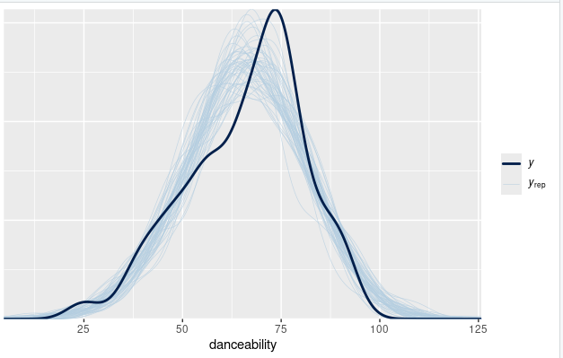

> pp_check(spotify_model_2) +
+ xlab("danceability")

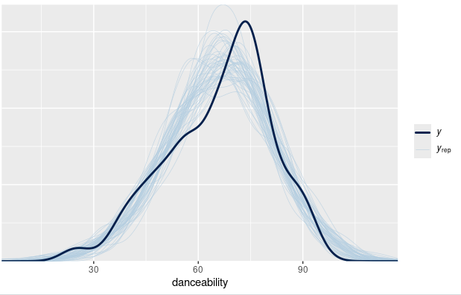

# Calculate ELPD for the 2 models
> elpd_spotify_1 <- loo(spotify_model_1)
> elpd_spotify_2 <- loo(spotify_model_2)
Warning message:
Found 1 observation(s) with a pareto_k > 0.7. We recommend calling 'loo' again with argument 'k_threshold = 0.7' in order to calculate the ELPD without the assumption that these observations are negligible. This will refit the model 1 times to compute the ELPDs for the problematic observations directly.

> # Compare the ELPD
> loo_compare(elpd_spotify_1, elpd_spotify_2)
elpd_diff se_diff
spotify_model_2 0.0 0.0
spotify_model_1 -5.4 3.0
> tidy(spotify_model_1, effects = "fixed",
+ conf.int = TRUE, conf.level = 0.80)
# A tibble: 7 × 5
term estimate std.error conf.low conf.high
<chr> <dbl> <dbl> <dbl> <dbl>
1 (Intercept) 53.3 3.05 49.3 57.1
2 valence 0.258 0.0334 0.215 0.300
3 genrelatin 0.415 3.53 -4.15 5.00
4 genrepop 0.486 2.70 -2.94 3.86
5 genrer&b -2.39 2.88 -6.07 1.28
6 genrerap 1.72 3.11 -2.29 5.67
7 genrerock -6.78 4.18 -12.0 -1.40
> # Plot the posterior models of the genre coefficients
> mcmc_areas(spotify_model_1, pars = vars(starts_with("genre")), prob = 0.8) +
+ geom_vline(xintercept = 0)

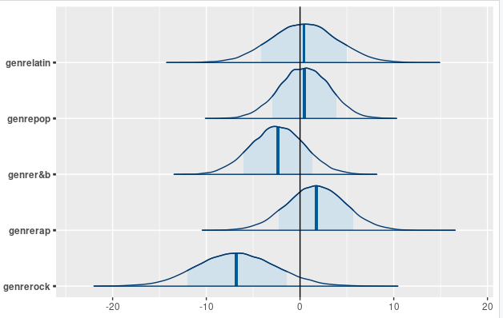

tidy(spotify_model_1, effects = "ran_vals",
+ conf.int = TRUE, conf.level = 0.80) %>%
+ filter(level %in% c("Camilo", "Missy_Elliott")) %>%
+ select(level, estimate, conf.low, conf.high)
# A tibble: 2 × 4
level estimate conf.low conf.high
<chr> <dbl> <dbl> <dbl>
1 Camilo -1.92 -7.21 3.40
2 Missy_Elliott 8.81 3.07 14.7
> # Simulate posterior predictive models for the 3 artists
> set.seed(84735)
> predict_next_song <- posterior_predict(
+ spotify_model_1,
+ newdata = data.frame(
+ artist = c("Camilo", "Mohsen Beats", "Missy Elliott"),
+ valence = c(80, 60, 90), genre = c("latin", "rock", "rap")))
> # Posterior predictive model plots
> mcmc_areas(predict_next_song, prob = 0.8) +
+ ggplot2::scale_y_discrete(
+ labels = c("Camilo", "Mohsen Beats", "Missy Elliott"))
Scale for y is already present.
Adding another scale for y, which will replace the existing scale.

